Airsports Live Tracking user manual

Table of Contents

Introduction 1

Site overview 2

Live tracking map 2

Events 3

Gaining management access 4

Contest management 4

Terms 4

Contest 4

Navigation Task 4

Team 4

Club 4

Contestant 5

Person 5

Tracking ID 5

Creating a contest 5

Entering teams 6

Creating a navigation task 6

Adding contestants 8

Navigation task information 8

Time schedule 8

Contestant map 9

Running a navigation task 9

FlightContest Integration 10

# Introduction

Airsports Live Tracking (<https://airsports.no>) is a live tracking and scoring platform for flying competitions. Currently it supports several variations of precision flying and air navigation race competitions, with more to come. It provides a visualisation of the competition track together with live tracking of the competing aircraft and on-the-fly calculation of aircraft scores.

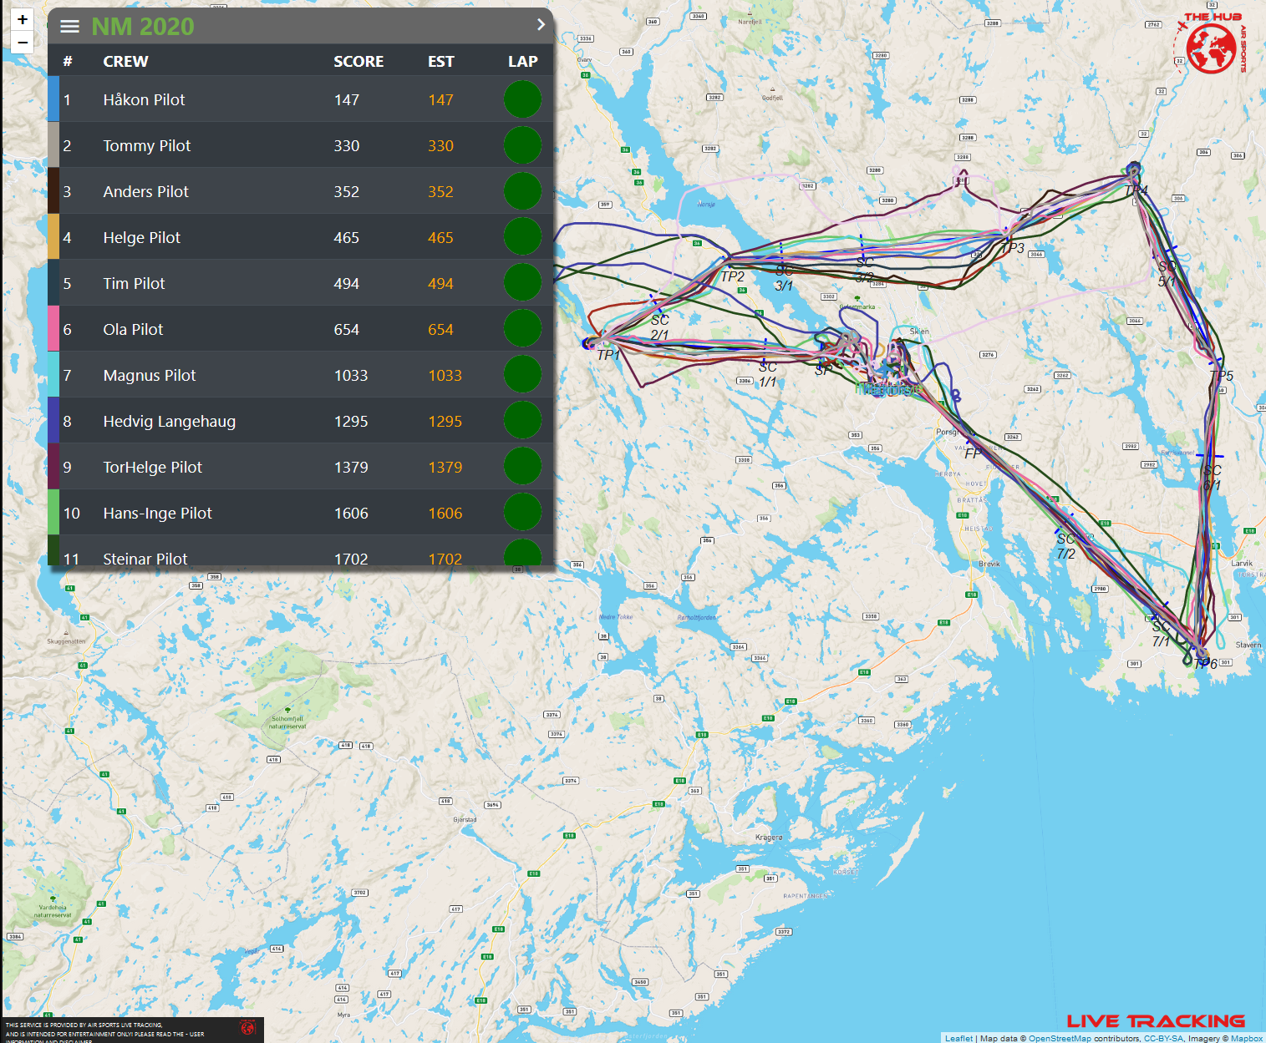

Figure 1 Airsports Live Tracking competition map

In addition Airsports Live Tracking provides live tracking of any aircraft that is actively submitting tracking data to the platform. At this is displayed on a separate tracking map which also visualises any ongoing or future events. It is therefore your go to platform for quickly checking where there is flying activity when planning your Saturday afternoon flight.

This document describes the management functionality provided through Airsports Live Tracking. Using the platform for viewing competitions or regular aircraft tracking is quite intuitive and requires no separate documentation.

# Site overview

## Live tracking map

The main site of airsports.no is the live tracking map that shows all active aircraft in the system, together with ongoing and upcoming events. The pages publicly available and requires no user account in the system. There is a button for signing into the site in the title bar of the events menu:

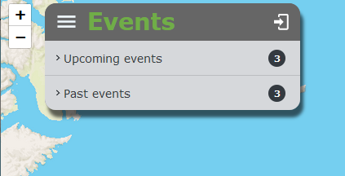

Figure 2 Sign in button

Any user with a user account in the system can sign in if desired, but this gives no additional functionality unless the user has the necessary privileges to perform management. This is indicated by the existence of a settings “cog” in the events menu after logging in.

Login is performed using the same email address that has already been used in the Android or iOS app or Airsports MSFS2020 Client. However, the postcode is different. To gain access you therefore need to click on “Forgotten password” on the login page to set a password for the site.

It if you do not already have a user account, contact support@airsports.no.

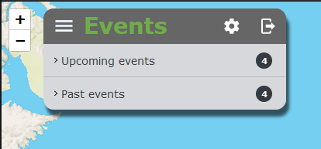

Figure 3 Settings button

If this button is available, you have access to perform site management. This is accessed through clicking on the cog, which will reveal the contest management page (Figure 4 Contest management page). 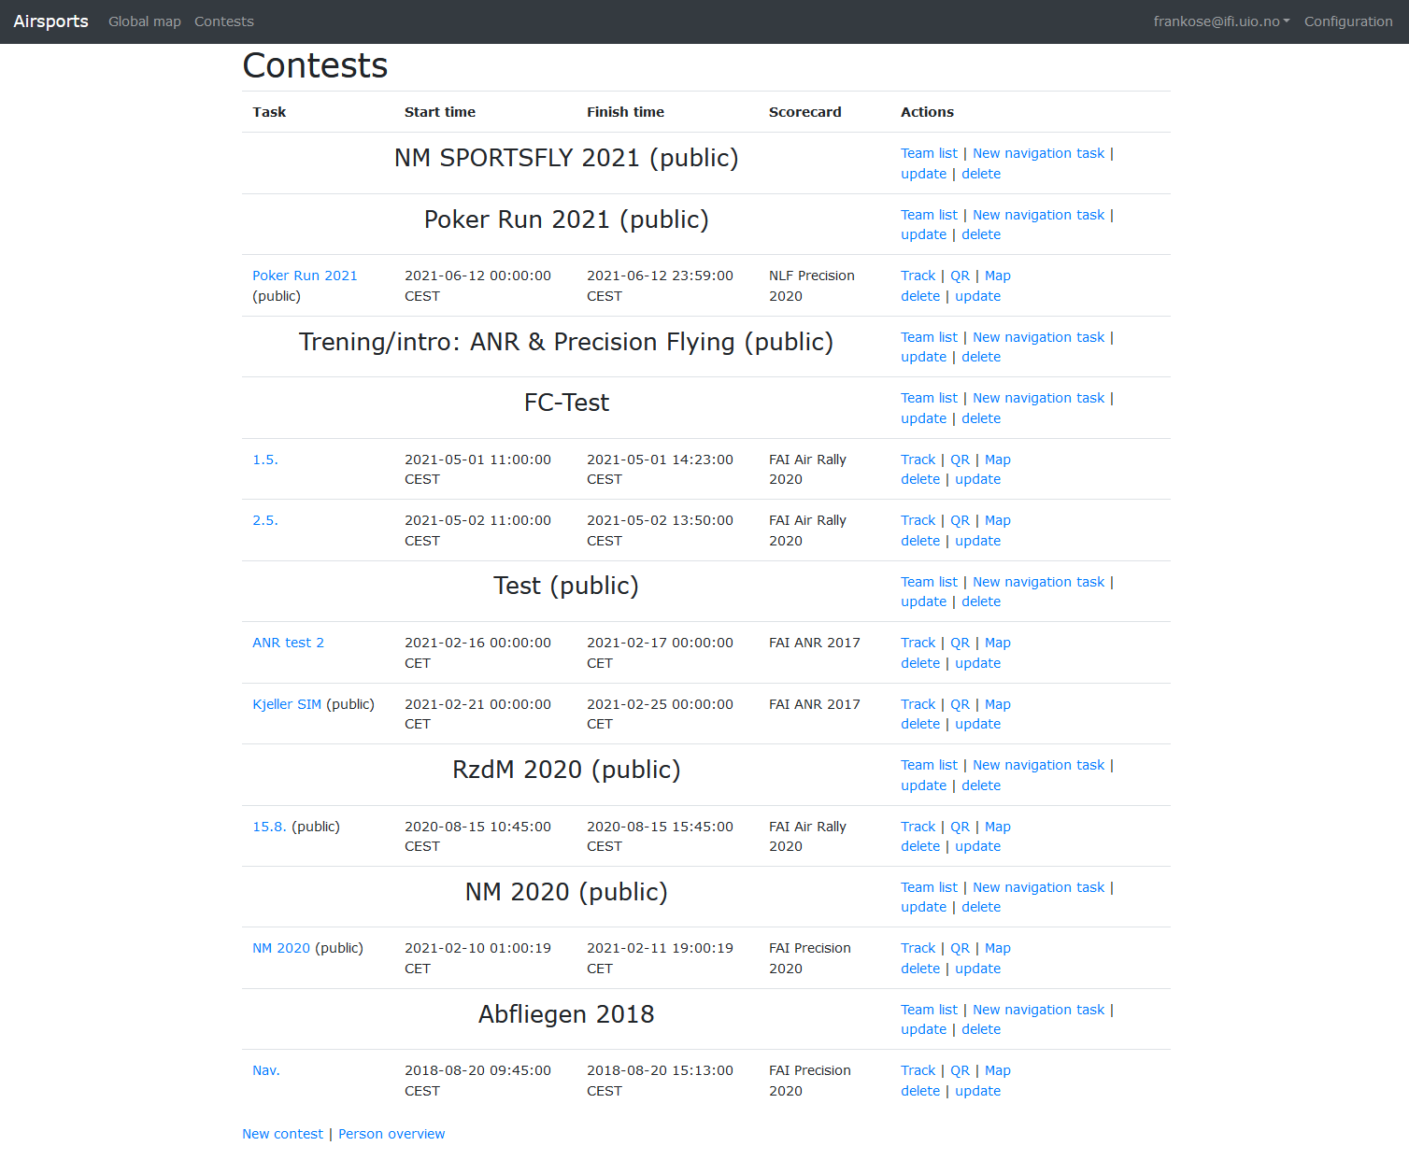

Figure 4 Contest management page

## Events

The event list on the live tracking map page can be expanded to display a list of ongoing and upcoming events. In the management section an event is referred to as a contest. By clicking on a specific event, the map will zoom to the location of the event and display an information box for the event and any tasks that are part of the event. Clicking on individual task names will redirect the user to the competition map for that task.

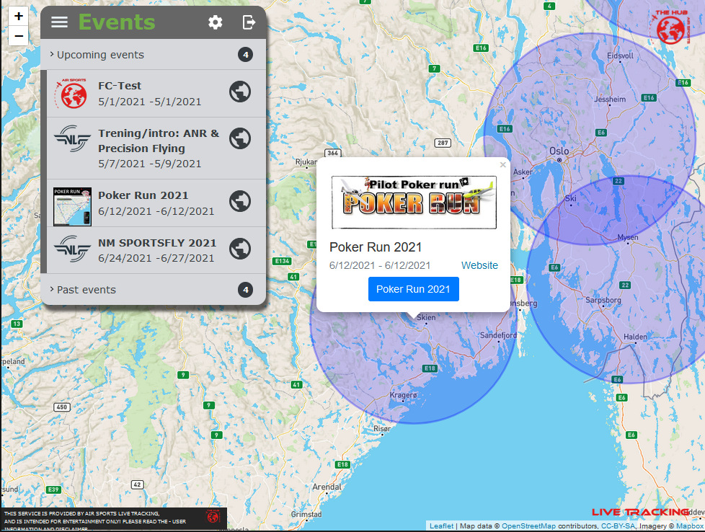

Figure 5 Event details

## Gaining management access

Users do initially not have privileges to create and manage events/contests. To apply for these privileges, please contact [support@airsports.no](mailto:support@airsports.no).

# Contest management

This section describes the mechanisms available for creating and managing contests. Before we go into the details, however, let’s start with defining the terms used.

## Terms

### Contest

The contest (“event” on the live tracking map) is the highest level data structure for the platform. It describes a single flying competition that may cover multiple days and consist of multiple tasks. For instance, a contest can be the World Championships 2021 which will typically go on for a week with multiple tasks (navigation, landing, planning, etc).

### Navigation Task

A navigation task is a task that is tracked by Airsports Live Tracking. For now this can be either a precision flying task or a air navigation race (ANR) task. The task consists of a route and a set of contestants (the teams flying the task).

### Team

A team is the entity that competes in a contest. It consists of a *crew* with a pilot and optional copilot, and an aircraft. When creating a contest, teams can be created and assigned to that contest. A team is a unique entity in the system and can take part in multiple contests.

### Club

A club represents the association of a team. For a local competition this will typically be the flying club of the contestants, while for an international contest will maybe be the nation the team is representing.

### Contestant

A team that is assigned to a contest can be added to a navigation task as a contestant. While the team contains details about who is participating, a contestant contains details relevant for the specific navigation task. This includes takeoff time, landing time, planned flying speed, wind information, and so forth.

### Person

A person is a unique object in the platform identified by the email address. A person can be the pilot or copilot of a crew, and is associated with the tracking app for Android and iOS and the Airsports MSFS2020 Client application whenever the user signs into these applications with the same email address. Think of a person as a profile that describes the individual with name, email address, a short biography, a nice profile picture, and so on.

### Tracking ID

The tracking ID is the identifier of the tracking device to be used for the team. If the team is flying with a hardware Tracker this idea has to be provided by the contest manager. If, however, the team is flying with either the android or iOS app, the tracking will be resolved by matching the tracking ID internal to the app with the person logged into the app. In other words, either of the team members (but only one) can run the tracking app and the system will correctly identify the team (actually the contestant) without the contestant manager having to provide such information.

A tracking ID is specific to a tracking service. Currently the platform only supports a single tracking service, Traccar.

## Creating a contest

To create a contest, and to the management page by clicking the cog icon on the live tracking map. At the bottom of the page is a link to create a new contest.

Information required for the contest is:

1. Name: A nice and understandable (short) name for the contest.
2. Time zone: This is required in order for all the times to be displayed for the local time zone of the contest
3. Start time: The start time for the contest
4. finish Time: The finish time for the contest
5. Is public: Is used to hide contests from everyone else until it is ready. For instance, it is undesirable to display the competition map before all the contestants have been sequestered in their isolation area.
6. Contest location (latitude, longitude): Although not strictly necessary, that is used to localise and display the contest on the live tracking map.
7. Publicity
   1. Contest website: The URL of the official contest website so that it can be displayed on the live tracking map.
   2. Header image: A nice banner image which is displayed above the contest information on the map.
   3. Logo: A small logo which is displayed next to the neck of contest in the event list.

Required fields are highlighted with a “*”.

Creating a contest with location information is sufficient to have an event show up on the live tracking map. The start and finish times will determine whether the contest will be displayed depending on whether the contestants in the past, ongoing, near in the future, or far into the future.

### Entering teams

After having created a contest, the next step is to register the teams that will participate in the contest. A team can compete in multiple navigation tasks, but need not compete in all.

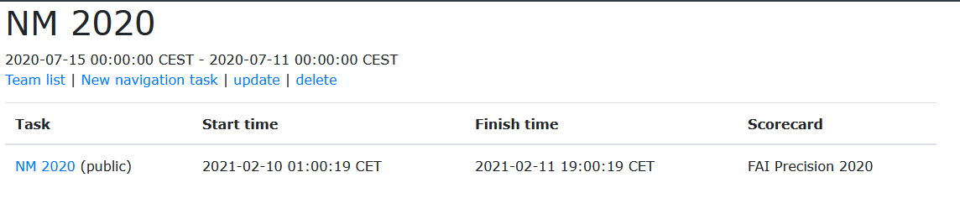

Figure 6 Contest overview

To access the team list for a contest, click the “Team list” link on the contest details page. This reveals a list of teams registered for the contest, with a link at the bottom to add additional teams.

Clicking “Add team” guides you through a team registration wizard with multiple steps. This helps you put together a team with already registered people or new people, existing or new aircraft, and existing or new clubs.

The first step is to search for existing pilots. You can search by first name, last name, email address, or phone number. If the correct person is found, click “Use existing pilot” to select this lack of person as the pilot. If you do not find the correct person, click “Create new pilot” in order to enter the details of a new person that is to be the pilot of the team. On the next screen it is possible to select the copilot in the same manner, or click “skip copilot” if there is a single person in the aircraft.

Once the persons have been selected, the next screen allows selecting and existing aircraft (by registration) or entering the details of a new aircraft. Similarly, flying club is selected in the same manner.

The final page in the wizard shows a summary of what has been selected for the team and allows adding a default flying speed for the contest, together with a default tracking ID (tracking ID is not required if team is using the Android or iOS app to track the flight).

## Creating a navigation task

A navigation task is the actual flying task that the teams will perform. A contest can consist of multiple navigation tasks, and contestants are added to the navigation task from the teams registered for the contest.

Creating a new navigation task is started by clicking the “New navigation task” link on the contest details page (Figure 6 Contest overview). This triggers a wizard to create a new navigation task.

During the first step of the wizard, you select the type of task you wish to create, either a position flying task, or an air navigation race. This determines which flying rules can be applied and how the track is displayed and scored.

#### Route import

The second step in the new navigation task wizard is importing the task route. Currently three file formats for describing the route are supported:

1. Google Earth KML/KMZ (preferred)
2. FlightContest gpx file (preferred if available)
3. CVS (mostly for internal use)

##### ANR

If you have selected a ANR task, route import is relatively simple. Create a path in Google Earth by clicking the path icon  and draw the route you wish to fly. Call this path “route”. To define a takeoff gate and landing gate, draw a similar line across the runway where you want the gate and call it “to” and “ldg” respectively.

It is also possible to define polygons  that represent prohibited areas. These can be used to mark control zones and other prohibited areas, or to build the ANR track without specifying the route. Each polygon has to have a name starting with “prohibited_”, where anything can be added after the “_”. It is possible to define penalty rules so that points will be given whenever the contestant enters any of these prohibited areas.

After defining all the features, place them in a single folder inside Google Earth, right click the folder and select “save places as”. Choose a useful file name and kml as the extension.

To import the file, selected from the “Route import” step in the navigation task wizard and make sure that the file type selected is KML/KMZ.

##### Precision flying

If you have selected a precision flying task, importing the route is slightly more complex than for ANR. You create the route in Google Earth in the same manner as for ANR by building a path and naming it “route”. Take of gates and landing gates can be defined in the same manner, as well as prohibited zones, and the file is imported by selecting it after exporting from Google Earth and choosing “KML/KMZ” as file type like for ANR.

However, precision flying requires an additional step to define the route. After importing the KML file you will be presented with a form that lists all the waypoints he created in the path in Google Earth, together with a small map that shows the route. For each waypoint, assign a useful name to the waypoint, define the width of the gate, whether time or gate passing should be checked, and the type of the gate. Once you’re satisfied, click submit and we move on to entering the navigation task additional details.

#### Navigation task details

Enter the name, starting time, and finish time for the navigation task. Is public has the same effect as for a contest, it allows for hiding the navigation task until it is ready for public viewing. Note that both the contest and the navigation task must be public for the neck of navigation task to be visible for any other than the user that created it.

Depending on the choice of precision flying or ANR, you can choose the appropriate scorecard for the navigation task. The scorecards are based on official rule documents, and the context should be clear from the scorecard name.

Finally, input the number of minutes each contestant should have from takeoff to the starting point, and from the finish point to landing. The latter time should be sufficient to allow for congestion around the airport.

The final step of the navigation task wizard provides an opportunity for overriding certain parameters for the task scoring. The exact parameters will be different depending on task type, and the number of parameters it is possible to override will probably increase based on user requests.

## Adding contestants

Once a navigation task has been created, it will be listed below its contest on the contest page. By clicking on the name of the navigation task you will into the navigation to details page which contains a list of contestants for the task. This list will initially be empty.

The quickest way to add contestants to a navigation task is to click the link “Add contestants” at the top of the page. This will display a list of all teams registered for the contest, and you can select all the teams that should be part of the navigation task. Once the selection is complete, click optimise, and the system will schedule all the teams based on overlapping aircraft, overlapping trackers, overlapping crew, making sure that no team will overtake another. The result will be shown as a nice timeline chart when the scheduling is complete. This chart is available by clicking on the “Timeline” link at the top of the navigation task details page (contestant list). It is possible to update individual contestants by clicking on the team name to update wind information, starting time, et cetera.

The critical pieces of information for the contestant details page is:

* Tracking start time: The time from which the tracker will identify with this particular contestant
* Takeoff time: The time the contestant has to take off
* Finished by time: The time by which the contestant should have landed
* Tracking ID: If using a hardware tracker, this must contain the ID of the hardware tracker. If either of the crew are using the app, then this field must be empty.
* Wind information: This can be modified as the day progresses and the weather changes, but it must be set before tracking start time.

The “Remove contestants” link at the top of the navigation task details page will clear out all contestants for the navigation task.

The “QR” link provides a QR code that can be printed out and displayed to give a direct link to the live competition map.

## Navigation task information

### Time schedule

On the contestant list for a navigation task is possible to retrieve the timetable for an individual contestant by clicking on the wind speed and direction for the contestant. This reveals a table that displays the planned passing time for each gate in the route. As the contestant completes the track, this list will be updated with the actual passing time, the calculated offset, and any penalty points awarded around that gate.

### Contestant map

It is possible to generate a navigation map for each individual contestant. This will display the route at the desired scale, and the map will include a useful scale bar to ensure that it is printed at the correct scale.

By selecting “Include annotations” the map will be annotated with the typical annotations required for a competition map, including heading for each leg, planned passing times for each gate, and minute marks.

### Export results

Airsports.no includes a results service portal to provide tables with the standings for the contestants for the various tasks. By clicking the link “Export results” on the navigation task details page, the results from the navigation task or export it to the results service portal for the contest. From here it is possible to print the table as it is, or export the results as a CSV file.

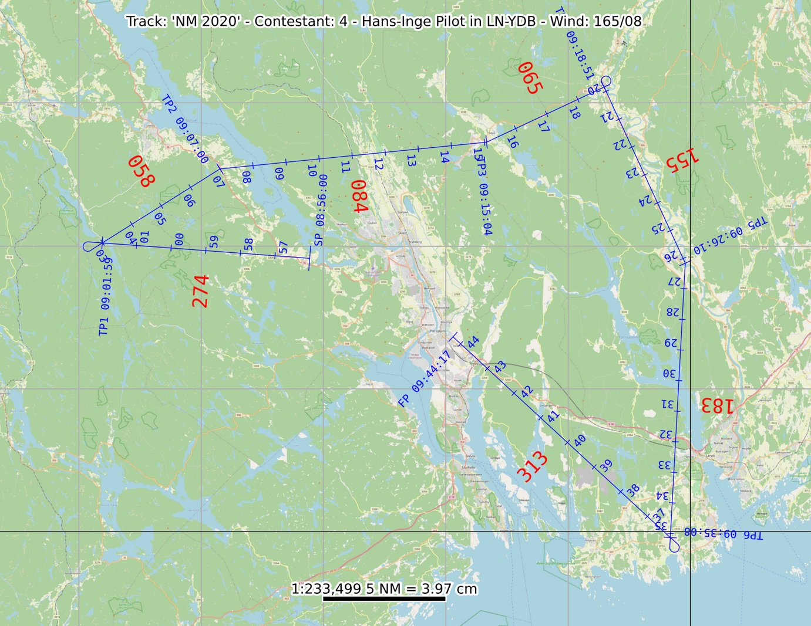

Figure 7 Annotated map with minute marks

There are several choices for background map:

* OSM: Open street map is possible to use for navigation, but not ideal. As global coverage.
* Norway 1:250000: A Norway specific topographic map

Additional maps can be added upon request.

# Running a navigation task

Once a navigation task has been created and contestants have been added, there is nothing more to do. The system will gather tracking information from the specified trackers (hardware trackers or apps) and scored the contestants as they progress along the route. There is a shortcut to the live competition map by clicking “Track” either next to the navigation task on the contest page, or at the top of the contestant list.

If the navigation task should be visible to the public, remember to make both the contest and the navigation task public.

## Modifying scoring

Each penalty assigned to a contestant is visible on the contestant timing page which is accessed by clicking on the wind column on the navigation details page. This shows a detailed breakdown of the expected and actual times for the waypoints in the route, together with all the penalties that have been applied. By clicking the link “Remove penalty” the penalty will be removed and the school will be adjusted accordingly. Note that this is irreversible, there is no functionality for adding additional penalties, yet.

# FlightContest Integration

FlightContest has created a tight integration with Airsport Live Tracking. To make use of this integration the easiest workflow is as follows:

1. Create a contest in Airsports Live Tracking.
2. Register the teams.
3. In FlightContest
   1. Import the contest
   2. Import the teams
   3. Create the navigation task
   4. Publish the navigation task to Airsports Live Tracking
4. After a contestant has landed, optionally import the flown track from Airsports Live Tracking for immediate analysis and scoring.